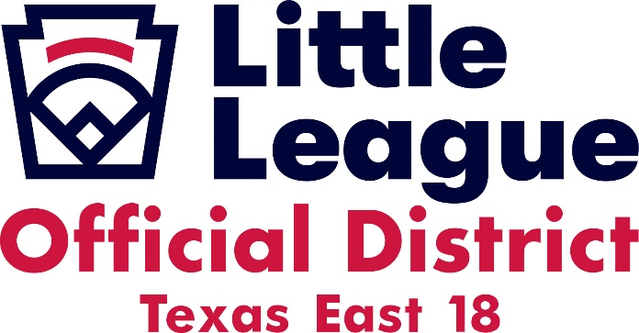

Hotel Information for El Campo, Texas

Each team is responsible for their accommodations. All the following hotels have rooms blocked off for those needing a room for the State Tournament. Please let them know that you are coming in with Little League so you will receive the discount rate.

Best Western Executive Inn
25880 US 59 Road
El Campo, Texas 77437
979-543-7033

Days Inn by Wyndham
25060 US 59 Road
El Campo, Texas 77437
979-320-8878

Home2 Suites by Hilton
25268 US 59
El Campo, Texas 77437
979-488-9795

Thank You,
Paul Sanders
Cell 979-541-6630
sb-umpire@swbell.net
Little League Baseball Inc.
District Administrator
Texas District 18
Texas East Section 4

